Final Project Part 2 by Andrew Lazar

Part 2 of the final was completed following all of the steps and even includes some features not posted on the project doc. New customers are added to the database only when one with the same phone number does not exist. Customers cannot skip past the pizza, sides or drink select page without choosing and option and entering a quantity that is an integer otherwise an error with display. Once a customer submits their order or chooses to return to the homepage, their previous input is wiped such that it acts as if they have not been to the page before. If a customer submits an order, it is added to the ordereditems database and the orders database which then updates the data table on the past orders page as shown below.

Homepage:

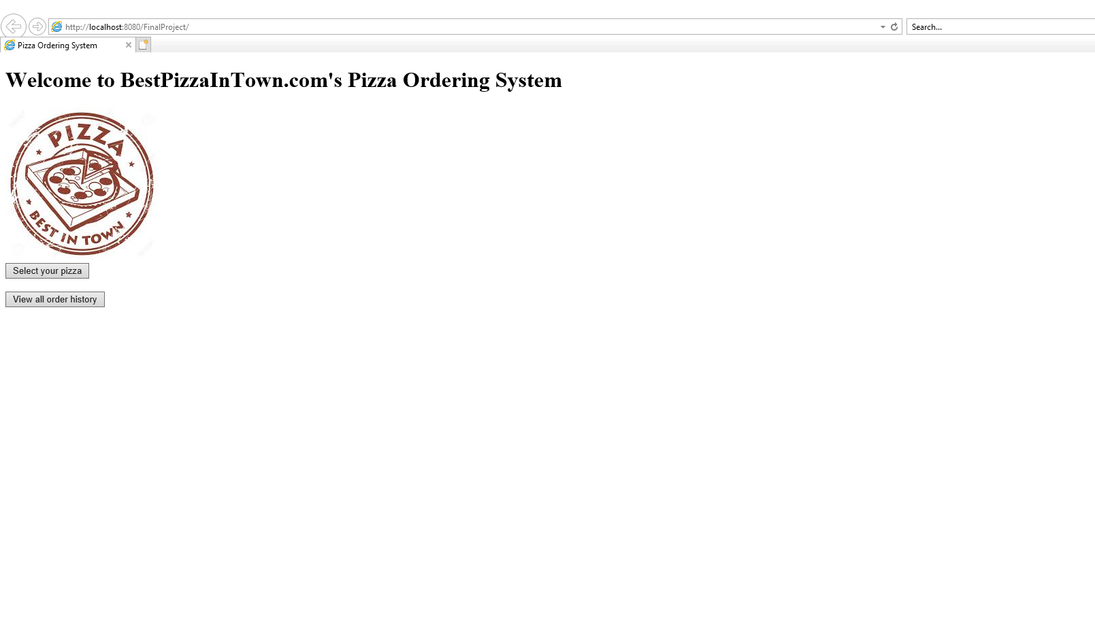

Database table before any orders added:

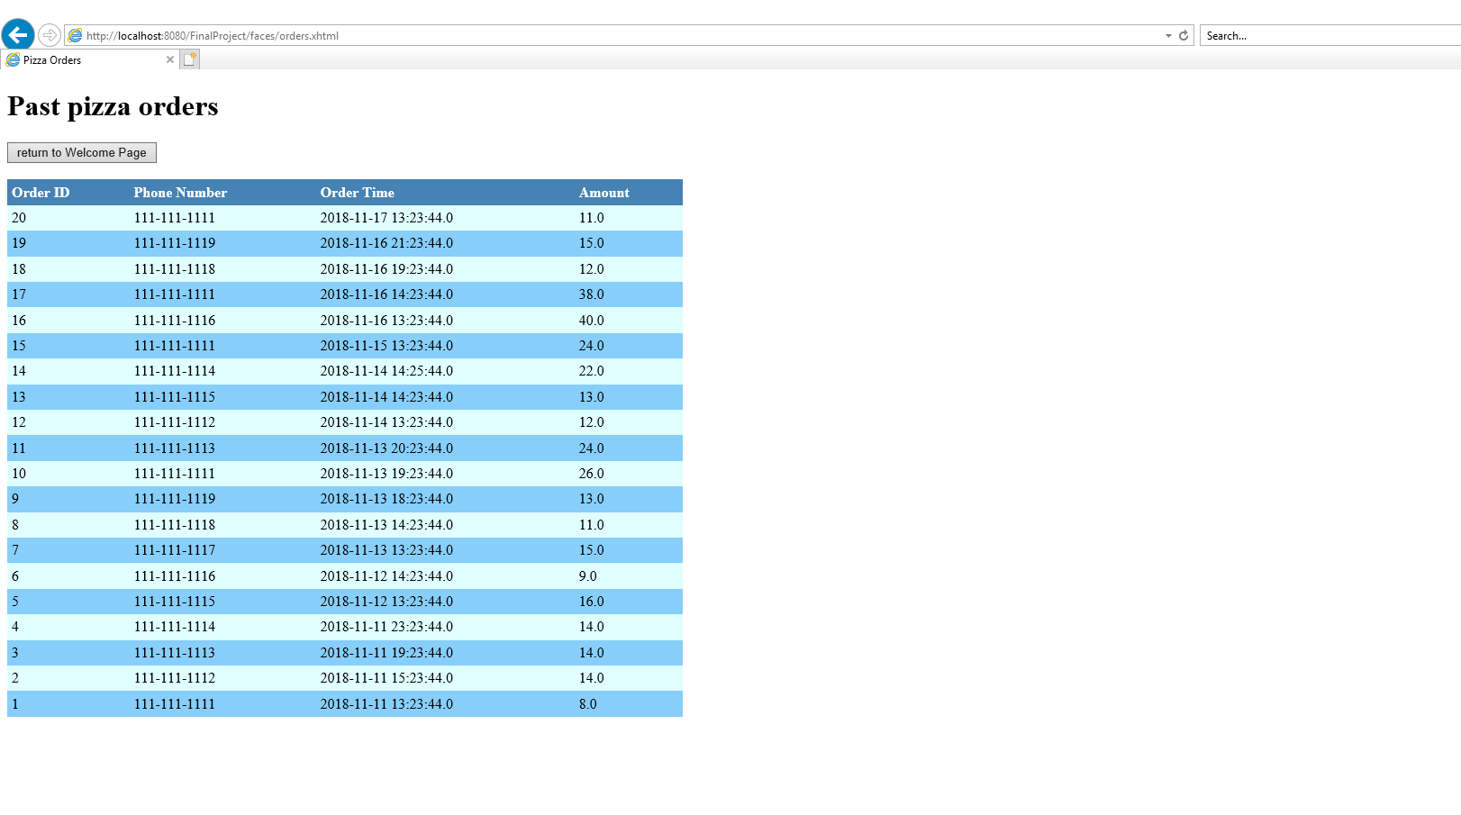

pizza select page:

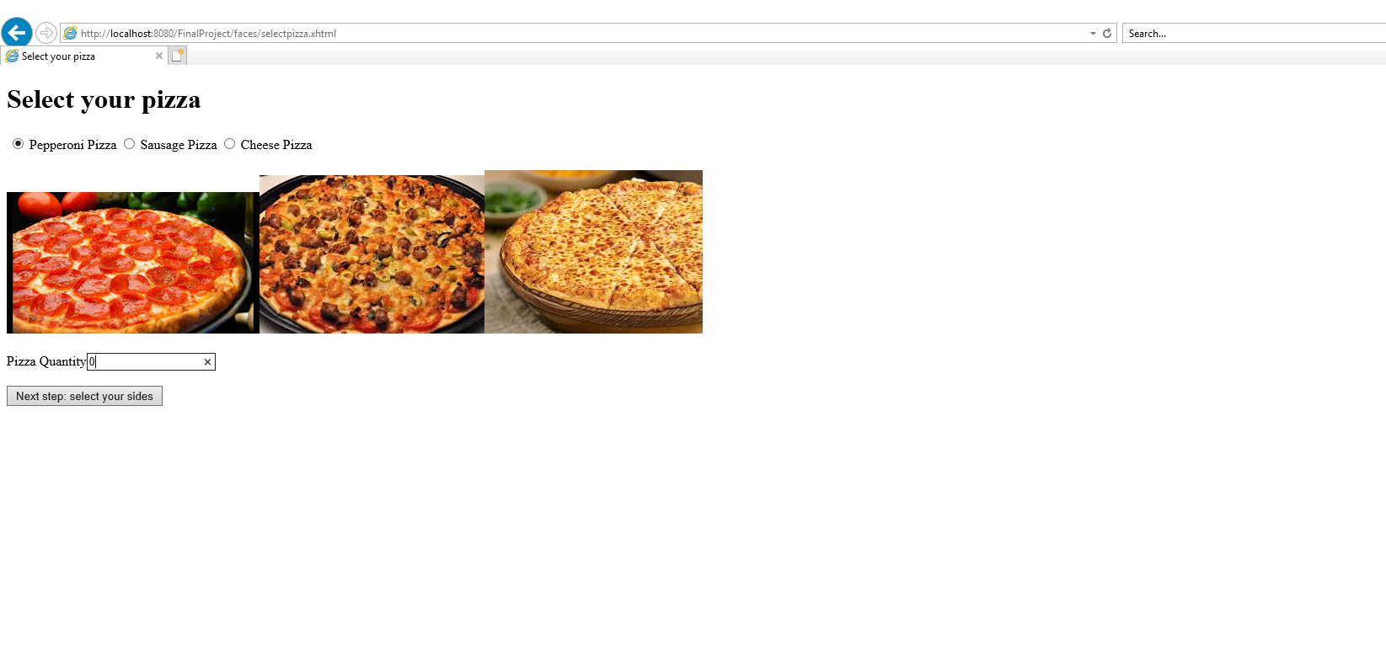

side select page:

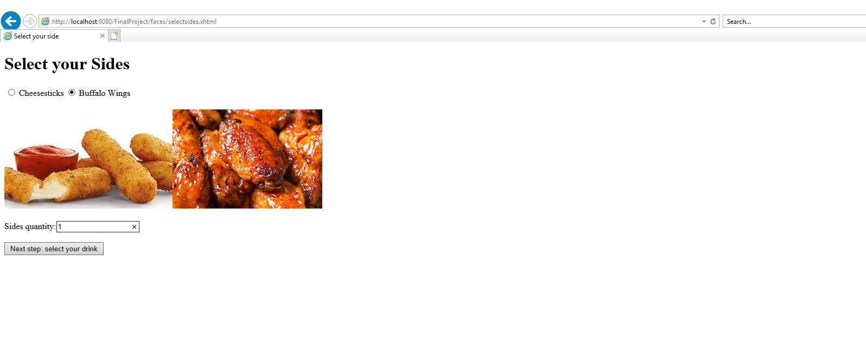

drink select page:

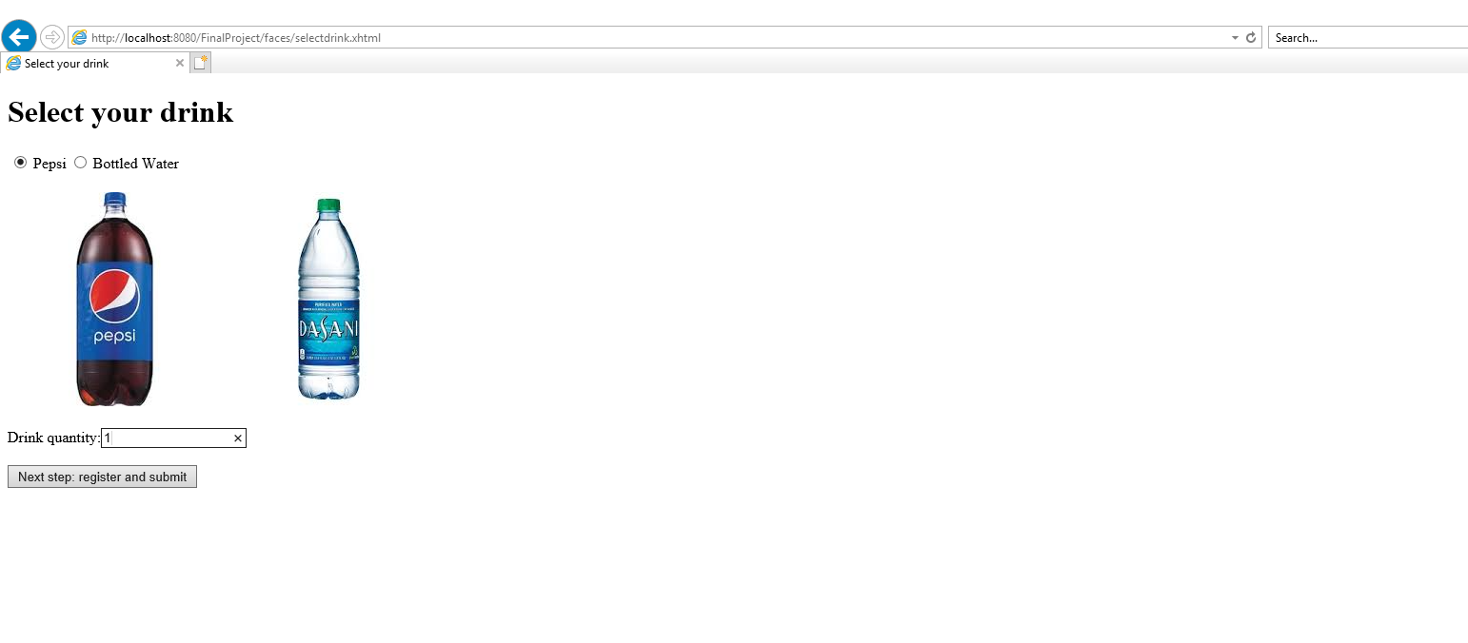

register2submit page:

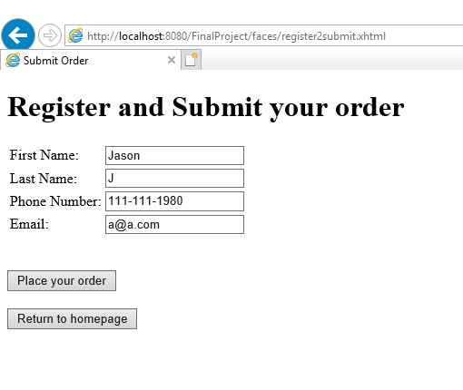

register2submit with input errors:

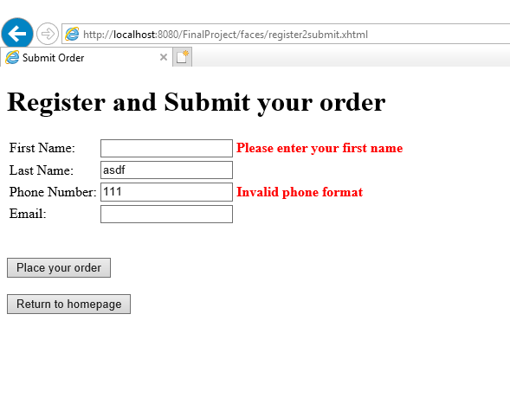

database table after order submitted:

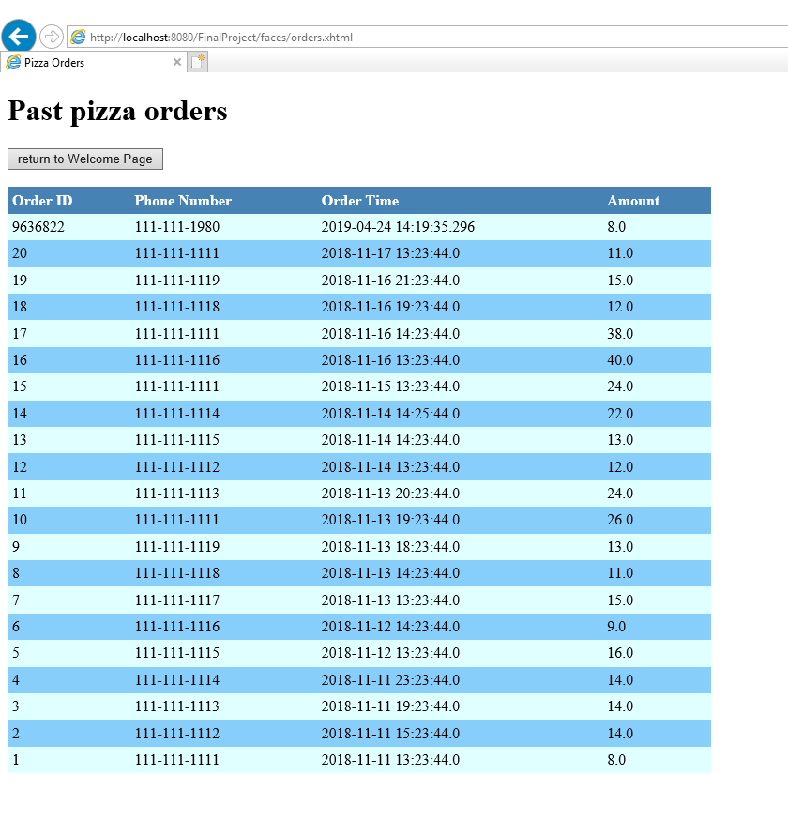

customer database after order created for new customer:

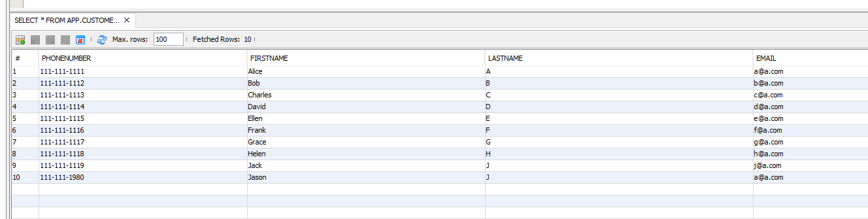

ordereditems database after order:

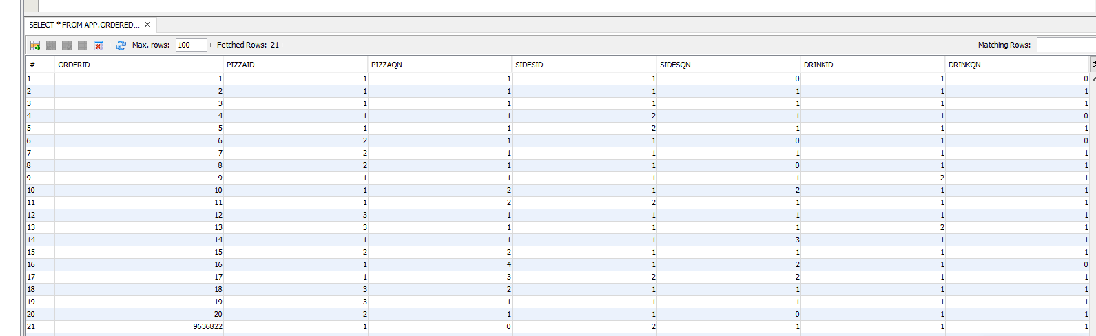

orders database after order:

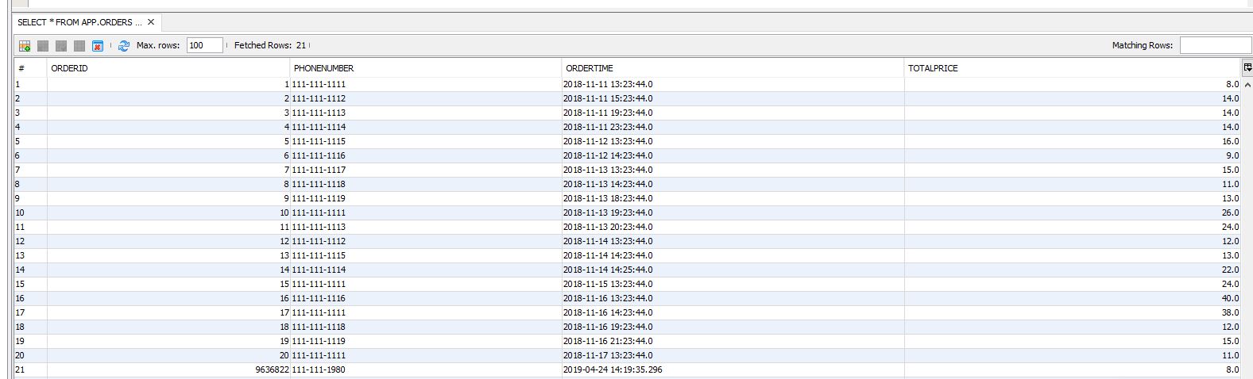

console output:

